**CHAPTER-1**

**INTRODUCTION**

This Project aims to model the working of an Airline Reservation System. This Project uses PHP as the Language.

The Airline reservation system, as the name goes provides services to the travelers. It reserves seats for its customers, maintains information and also updates the database.

This project is based on the 2-tier architecture. The Project is developed keeping in mind the security needs of today.

The project is totally built at administrative end and thus only the administrator is guaranteed the access.

The purpose of the Airline Reservation System Project is to build a website, which an airline could use to manage the reservation of airline tickets.

Passengers make flight reservations through the website of the airline, which can make easy way to check on flight details.

The system able to create flights, delete flights and reserve seats for passengers according to their requested Destination, day and time.

**CHAPTER-2**

**PHP**

PHP is a server scripting language, and is a powerful tool for making dynamic and interactive Web pages quickly.

**2.1 What is PHP?**

PHP is a widely-used, free, and efficient alternative to competitors such as Microsoft's ASP.

* PHP is an acronym for "PHP Hypertext Preprocessor"
* PHP is a server scripting language, and is a powerful tool for making dynamic and interactive Web pages quickly.
* PHP is a widely-used, free, and efficient alternative to competitors such as Microsoft's ASP.
* PHP is a widely-used, open source scripting language
* PHP scripts are executed on the server
* To increase the knowledge among users.
* To minimize the paper work.
* PHP is a widely-used, open source scripting language
* PHP scripts are executed on the server
* PHP costs nothing, it is free to download and use

## What is a PHP File?

* PHP files can contain text, HTML, CSS, JavaScript, and PHP code
* PHP code are executed on the server, and the result is returned to the browser as plain HTML
* PHP files have extension ".php"
  1. **Objective:**
* To minimize the paper work.
* PHP is a widely-used, open source scripting language
* PHP scripts are executed on the server
* PHP costs nothing, it is free to download and use

**2.3.1 Characteristics of PHP:**

* PHP runs on various platforms (Windows, Linux, Unix, Mac OS X, etc.)
* PHP is compatible with almost all servers used today (Apache, IIS, etc.)
* PHP supports a wide range of databases
* PHP is free. Download it from the official PHP resource: www.php.net
* PHP is easy to learn and runs efficiently on the server side
  1. **Basic Syntax of Php**
* A PHP script can be placed anywhere in the document.
* A PHP script starts with **<?php** and ends with **?>**:

**<?php  
 //**php code

**?>**

* 1. **Ewample of php file**

An ewample of a simple PHP file, with a PHP script that uses a built-in PHP function "echo" to output the text "Hello World!" on a web page:

<html>

<body>

<h1>My first php page</h1>

<?php

echo”hello World”;

?>

</body>

</html>

**CHAPTER-3**

**WAMP SERVER**

WampServer is a collection of web development tools and softwares. The application contains Apache Web Server, MySQL Database Management System & PHP Programming Language. This program provides an environment for developing web pages and applications.

**Step1:** First of all download the Latest Wamp server from here:

http://www.wampserver.com/

**Step 2:** Run Wamp server by this selection

start->All programs->Wamp server->Start Wamp server



Figure 3.1: Wamp server icon

**Step3:** Now you can see the w icon in system tray.

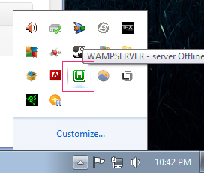

Figure 3.2: Screen shot after Wamp server started

An icon will appear on the icon tray. "Green" icon indicates that all the services have started. "Red" indicates that all the services have stopped. You can put the server online (so that user can access the server over the Internet) by selecting the option "Put Online". Alternatively, you could put the server "Offline", such that it is accessible only within the localhost.

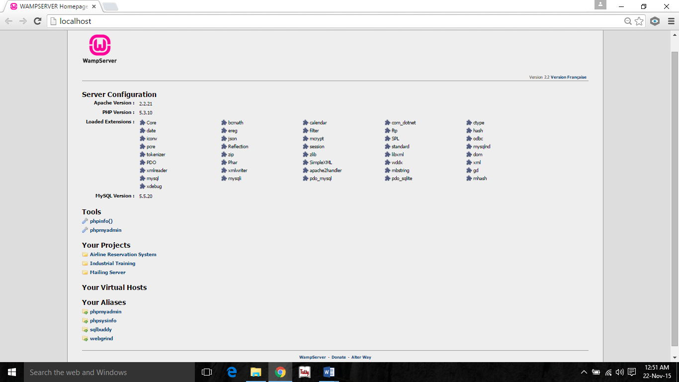

Figure 3.3: Wamp server window

It is time to test our Wamp Server with the installed services of Apache, PHP, MySql and phpMyAdmin. Please follow the steps to test Wamp Server at Windows 7.

* Be sure, Wamp Server icon is green/orange at taskbar
* Open your favorite browser
* Type, http://127.0.0.1/ OR http://localhost/
* Hit Enter

OR

* Be sure, Wamp Server icon is green/orange at taskbar
* Click on Wamp server icon in the system tray
* Click localhost

You have successfully installed Wamp Server on your computer if you have seen the welcome screen of Wamp Server. You can read Server Configuration at Wamp Server welcome screen.

* Apache Version: 2.2.17
* PHP Version: 5.3.4
* Loaded Extensions: Loaded extensions of PHP
* MySql Version: 5.1.53 – It will be Mysql 5.5.8 at 32 bits platform.

**CHAPTER-4**

**MYSQL**

A database management system must be able to reliably manage a large amount of data in a multi-user environment so that many users can concurrently access the data. A database management system should also provide security and failure recovery.

MySQL is the name of a database management system Developed by Apache Software Foundation. Apache Software Foundation provides various softwares related to web development; the biggest advantage is that all the software’s are free of cost. MySQL is most popular database management tool. It provides better security and data recovery against system failure.

MySQL works faster compared to other Database Management tools. Apache Software Foundation provides GUI to work with MySQL, because of its GUI environment it is very easy to understand any novice user can quickly learn MySQL by using phpMyAdmin developer. We can create databases and maintain it through phpMyAdmin developer. It provides GUI so it is easy to understand and learn.

MySQL is a database management system, which helps us to manage data stored in a system database. Programming skills is not required to use MySQL as database management system. phpMyAdmin hides all the complex tasks of managing a database and gives a user-friendly way of managing a database.

In phpMyAdmin of MySQL you can use some features of other package i.e. you can also write query in SQL form for better use and we can also connect it to other database management tools like Microsoft Access. It is so simpler and easier for novice users. A non professional Oracle user can also easily work with phpMyAdmin. The fundamentals of database management system like constraint, length, default value, and any other requirement is also fulfilled by this tool.

**4.1 Advantages of MySQL :**

* Written in C and C++.
* Tested with a broad range of different compilers.
* Works on many different platforms..
* Uses GNU Automake, Autoconf, and Libtool for portability.
* The MySQL Server design is multi-layered with independent modules.
* Fully multi-threaded using kernel threads. It can easily use multiple CPUs if they are available.
* Provides transactional and non-transactional storage engines.
* Uses very fast B-tree disk tables (MyISAM) with index compression.
* Relatively easy to add other storage engines. This is useful if you want to provide an SQL interface for an in-house database.
* A very fast thread-based memory allocation system.
* Very fast joins using an optimized one-sweep multi-join.
* In-memory hash tables, which are used as temporary tables.
* SQL functions are implemented using a highly optimized class library and should be as fast as possible. Usually there is no memory allocation at all after query initialization.
* The MySQL code is tested with Purify (a commercial memory leakage detector) as well as with Valgrind, a GPL tool.
* The server is available as a separate program for use in a client/server networked environment. It is also available as a library that can be embedded (linked) into standalone applications. Such applications can be used in isolation or in environments where no network is available.

#### 4.2 Advantages of Using PHP with MySQL

There are several factors that make using PHP and MySQL together a natural choice:

**4.2.1 PHP and MySQL work well together**

PHP and MySQL have been developed with each other in mind, so they are easy to use together. The programming interfaces between them are logically paired up. Working together wasn't an afterthought when the developers created the PHP and MySQL interfaces.

**4.2.2 PHP and MySQL have open source power**

As they are both open source projects, PHP and MySQL can both be used for free. MySQL client libraries are no longer bundled with PHP. Advanced users have the ability to make changes to the source code, and therefore, change the way the language and programs work.

**4.2.3. PHP and MySQL have community support**

There are active communities on the Web in which you can participate and they'll answer your questions. You can also purchase professional support for MySQL if you need it.

**CHAPTER-5**

**TECHNOLOGIES USED**

This whole project have 3 main technologies that are Html, php and MySQL. These all Technologies work together to form any type of web application. This will three layers View layer, Logic layer and database layer. As shown below.

Database

Logic

View

HTML PHP

MYSQL

Figure:-5.1 Layer

Php works on logical layer, MySQL works database layer and Html work on view layer. Now let’s discuss about each separately.

**5.1 PHP**

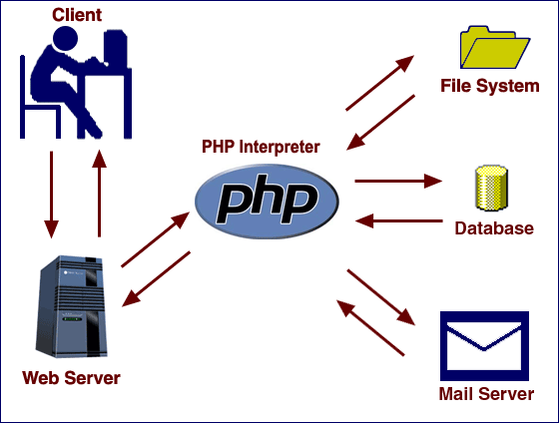

Figure:-5.2 PHP

PHP is a server-side scripting language designed for web development but also used as a general-purpose programming language. PHP is now installed on more than 244 million websites and 2.1 million web servers. Originally created by RasmusLerdorf in 1995, the reference implementation of PHP is now produced by The PHP Group. While PHP originally stood for Personal Home Page, it now stands for PHP: Hypertext Preprocessor, a recursive acronym.

PHP code is interpreted by a web server with a PHP processor module, which generates the resulting web page: PHP commands can be embedded directly into an HTML source document rather than calling an external file to process data. It has also evolved to include a command-line interface capability and can be used in standalone graphical applications.

PHP is free software released under the PHP License, which is incompatible with the GNU General Public License (GPL) due to restrictions on the usage of the term PHP. PHP can be deployed on most web servers and also as a standalone shell on almost every operating system and platform, free of charge

As shown in the diagram, the PHP interpreter processes the page, communicating with file systems, databases, and email servers as necessary, and then delivers a web page to the web server to return to the browser.

The PHP interpreter only executes PHP code within its delimiters. Anything outside its delimiters is not processed by PHP (although non-PHP text is still subject to control structures described in PHP code). The most common delimiters are <?php to open and ?> to close PHP sections. <script language="php"> and </script> delimiters are also available, as are the shortened forms <? Or <?= (which is used to echo back a string or variable) and ?> as well as ASP-style short forms <% or <%= and %>. While short delimiters are used, they make script files less portable as support for them can be disabled in the PHP configuration, and so they are discouraged. The purpose of all these delimiters is to separate PHP code from non-PHP code, including HTML.

The first form of delimiters, <?php and ?>, in XHTML and other XML documents, creates correctly formed XML 'processing instructions’. This means that the resulting mixture of PHP code and other markup in the server-side file is itself well-formed XML.

Variables are prefixed with a dollar symbol, and a type does not need to be specified in advance. Unlike function and class names, variable names are case sensitive. Both double-quoted ("") and heredoc strings provide the ability to interpolate a variable's value into the string. PHP treats newlines as whitespace in the manner of a free-form language (except when inside string quotes), and statements are terminated by a semicolon. PHP has three types of comment syntax: /* */ marks block and inline comments; // as well as # are used for one-line comments.

The echo statement is one of several facilities PHP provides to output text, e.g., to a web browser.

**5.2 MySQL**

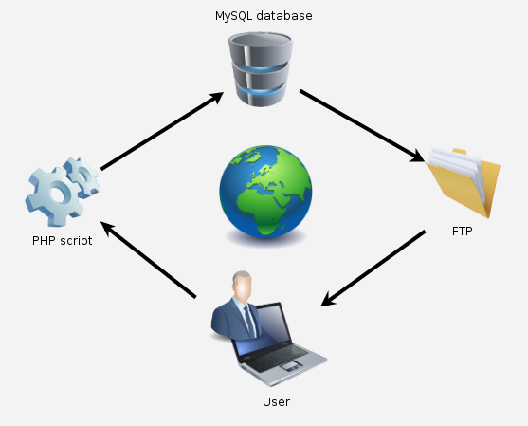

Figure 5.3 My SQL

MySQL is a relational database management system (RDBMS), and ships with no GUI tools to administer MySQL databases or manage data contained within the databases. Users may use the included command line tools, or use MySQL "front-ends", desktop software and web applications that create and manage MySQL databases, build database structures, back up data, inspect status, and work with data records. The official set of MySQL front-end tools, MySQL Workbench is actively developed by Oracle, and is freely available for use.

MySQL can be built and installed manually from source code, but this can be tedious so it is more commonly installed from a binary package unless special customizations are required. On most Linux distributions the package management system can download and install MySQL with minimal effort, though further configuration is often required to adjust security and optimization settings.

Though MySQL began as a low-end alternative to more powerful proprietary databases, it has gradually evolved to support higher-scale needs as well. It is still most commonly used in small to medium scale single-server deployments, either as a component in a LAMP-based web application or as a standalone database server. Much of MySQL's appeal originates in its relative simplicity and ease of use, which is enabled by an ecosystem of open source tools such as phpMyAdmin. In the medium range, MySQL can be scaled by deploying it on more powerful hardware, such as a multi-processor server with gigabytes of memory.

There are however limits to how far performance can scale on a single server ('scaling up'), so on larger scales, multi-server MySQL ('scaling out') deployments are required to provide improved performance and reliability. A typical high-end configuration can include a powerful master database which handles data write operations and is replicated to multiple slaves that handle all read operations. The master server synchronizes continually with its slaves so in the event of failure a slave can be promoted to become the new master, minimizing downtime. Further improvements in performance can be achieved by caching the results from database queries in memory using memcached, or breaking down a database into smaller chunks called shards which can be spread across a number of distributed server clusters.

MySQL works on many system platforms, including AIX, BSDi, FreeBSD, HP-UX, eComStation, i5/OS, IRIX, Linux, Mac OS X, Microsoft Windows, NetBSD, Novell NetWare, OpenBSD, OpenSolaris, OS/2 Warp, QNX, Solaris, Symbian, SunOS, SCO OpenServer, SCO UnixWare, Sanos and Tru64. A port of MySQL to OpenVMS also exists.

MySQL is written in C and C++. Its SQL parser is written in yacc, but it uses a home-brewed lexical analyzer. Many programming languages with language-specific APIs include libraries for accessing MySQL databases. These include MySQL Connector/Net for integration with Microsoft's Visual Studio (languages such as C# and VB are most commonly used) and the JDBC driver for Java.

**5.3 HTML**

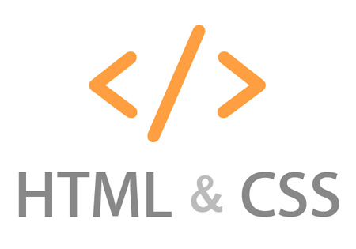

Hypertext Markup Language (HTML) is the main markup language for creating web pages and other information that can be displayed in a web browser.

HTML is written in the form of HTML elements consisting of tags enclosed in angle brackets (like <html>), within the web page content. HTML tags most commonly come in pairs like <h1> and </h1>, although some tags represent empty elements and so are unpaired, for ewample <img>. The first tag in a pair is the start tag, and the second tag is the end tag (they are also called opening tags and closing tags). In between these tags web designers can add text, further tags, comments and other types of text-based content.

The purpose of a web browser is to read HTML documents and compose them into visible or audible web pages. The browser does not display the HTML tags, but uses the tags to interpret the content of the page.

HTML elements form the building blocks of all websites. HTML allows images and objects to be embedded and can be used to create interactive forms. It provides a means to create structured documents by denoting structural semantics for text such as headings, paragraphs, lists, links, quotes and other items. It can embed scripts written in languages such as JavaScript which affect the behavior of HTML web pages.

Web browsers can also refer to Cascading Style Sheets (CSS) to define the appearance and layout of text and other material. The W3C, maintainer of both the HTML and the CSS standards, encourages the use of CSS over explicit presentational HTML markup.

Hypertext Markup Language is a markup language that web browsers use to interpret and compose text, images and other material into visual or audible web pages. Default characteristics for every item of HTML markup are defined in the browser, and these characteristics can be altered or enhanced by the web page designer's additional use of CSS. Many of the text elements are found in the 1988 ISO technical report TR 9537 Techniques for using SGML, which in turn covers the features of early text formatting languages such as that used by the RUNOFF command developed in the early 1960s for the CTSS (Compatible Time-Sharing System) operating system: these formatting commands were derived from the commands used by typesetters to manually format documents. However, the SGML concept of generalized markup is based on elements (nested annotated ranges with attributes) rather than merely print effects, with also the separation of structure and markup; HTML has been progressively moved in this direction with CSS.

**CHAPTER-6**

**SOFTWARE & HARDWARE REQUIREMENT**

**6.1 Software Requirements:**

**For Devloper**

* Notepad/Notepad++/Sublime Text:- It is used as the Front End for designing the interface and coding.
* Browsers:- Google Chrome, Opera, Internet Explorer, Mozilla Firefox, Microsoft Edge.
* Server:- WAMP server / XAMPP server.
* MS-word:- Microsoft Word is used as for maintain the documents.

**For User**

* Browsers:- Google Chrome, Opera, Internet Explorer, Mozilla Firefox, Microsoft Edge.
* Internet connection.

**6.2 Hardware required:**

* Screen Resolution : 1366*768 (recommended).
* RAM : 64 MB (128 MB recommended)
* Processor Type : 800 MHz (above), Intel Core i3
* Monitor Type : VGA with energy star Complaint for

Power Saving (Recommended)

* Operating System : Microsoft WindowsXP Professional , Windows 7 ServicePack-1 , Windows 8 , Windows 8.1 , Windows 10 (Any Newer operating System Launched by Microsoft)

**CHAPTER-7**

**DATA FLOW DIAGRAM**

DFD shows the flow of data. These diagrams help to understand the basic Working of the system. It helps to make and recognize various parts and their inter relationships. It is a way of expressing system requirement in a graphical form; this leads to a modular design. It is also known as bubble chart, has the purpose of clarifying system requirements and identifying major transformations that will become program in system design. So it is the starting point of the design phase that functionally decomposes the requirement specifications down to the lowest level of details. A DFD consist of a series of bubbles joined by lines. The bubbles represent data transformation and the lines represent data flows in the system.

**7.1 DFD SYMBOLS:**

= **Source or Destination of data**

= **Data flow**

## = Process that transform data flow

=**Data store**

**7.2 PURPOSE:-**

* Providing user friendly interface
* To store all the information about the patient online.
* Easy access of data
* Easy maintenance
* Maintaining data consistency
* Providing better performance
* Increasing the efficiency through automation
* Proper authorization

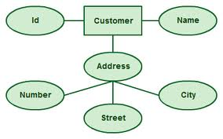

Figure 7.2: Data Flow

## 7.3 CODE DESIGN:

When large volumes of data are being handled, it is important that the item be identified, stored or selected easily and quickly. To accomplish this, each data item must have unique identification and must be related to other items of the same type. Codes can provide brief identification of each item, which replace longer description that would be more awkward to store and manipulate.

The ability to interrupt codes, evaluate coding schemes and devices new or improved codes are important skills for a system analyst. Common types of codes are:

**7.3.1 Sequence Codes:**

## A sequence code has no relation to the characteristics of an item. Here a dictionary is required. The data is arranged alphabetically and numbered sequentially. When a new data item is added it is given the next sequence number. The advantage of this code is that it has the ability touched with an unlimited number of digits.

## 1. Significant Digit Code:

It is a code in which the number describes measurable physical characteristics of the item.

2. Alphabetic Code:

## Here, the item are specified by the user of letter and number combinations,

## 3. Self-Checking Code:

It uses a check digit to check the validity of codes. These types of codes are an important means of controlling the validity of data that are being processed.

**CHAPTER-8**

**SCREENSHOTS OF AIRLINE RESERVATION SYSTEM**

* **Home Page:**

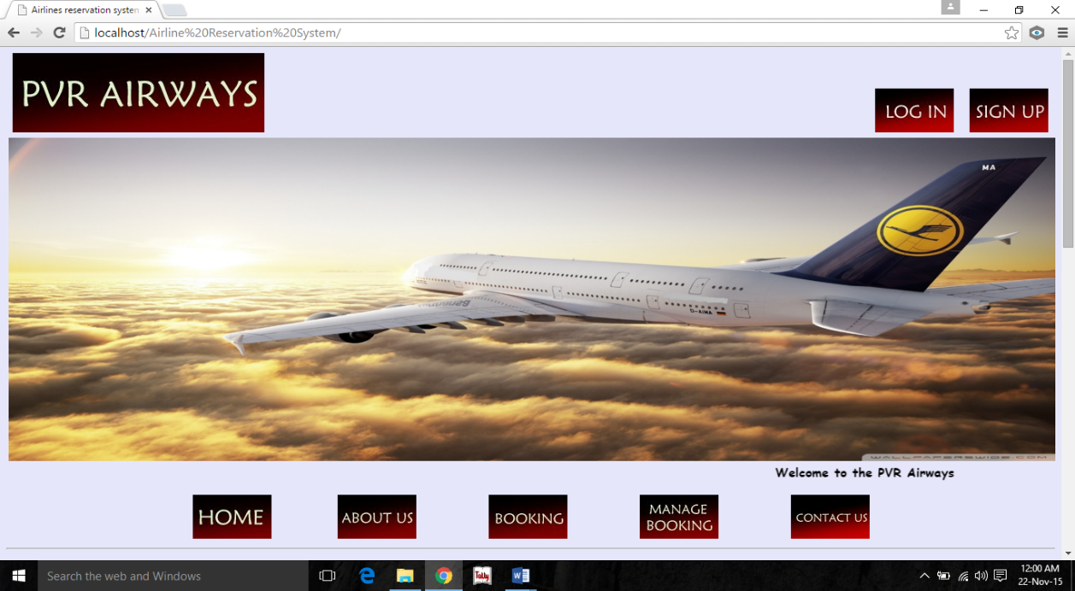

Figure 8.1 Home page

* **About Page:**

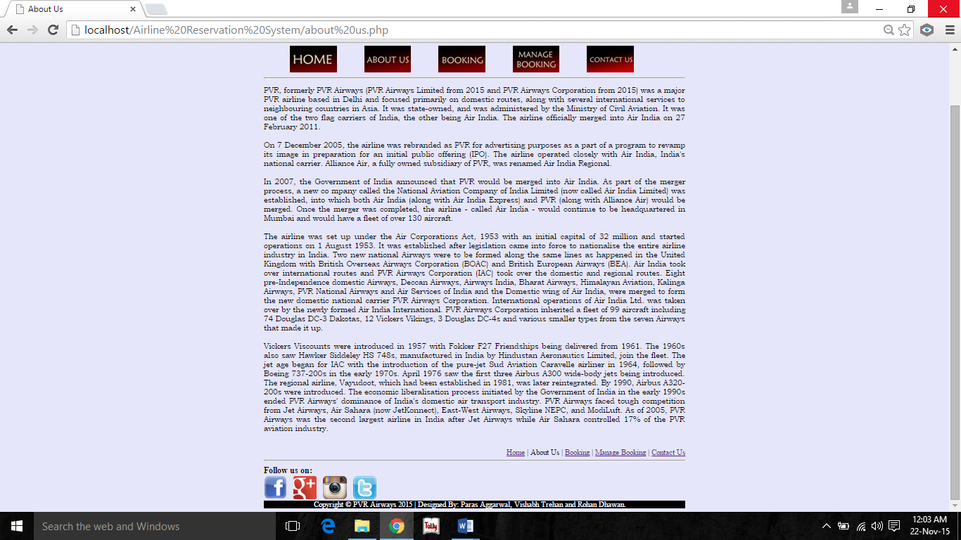

Figure 8.2 About Page

* **Login page**

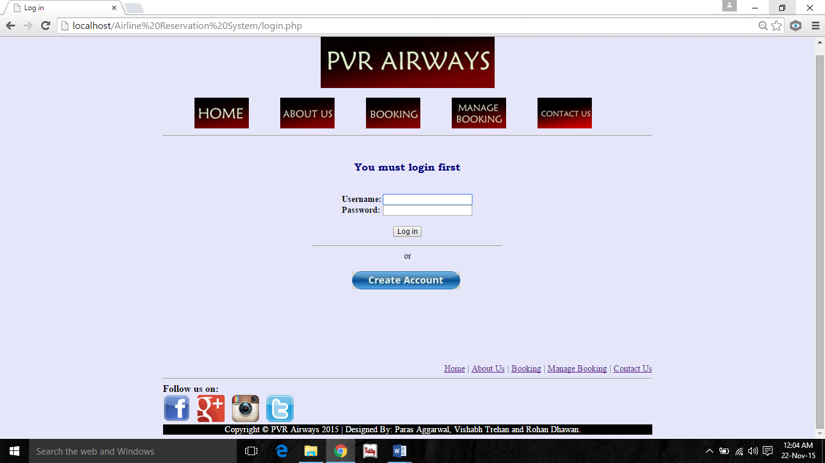

Figure 8.3 Login page

* **Register page:**

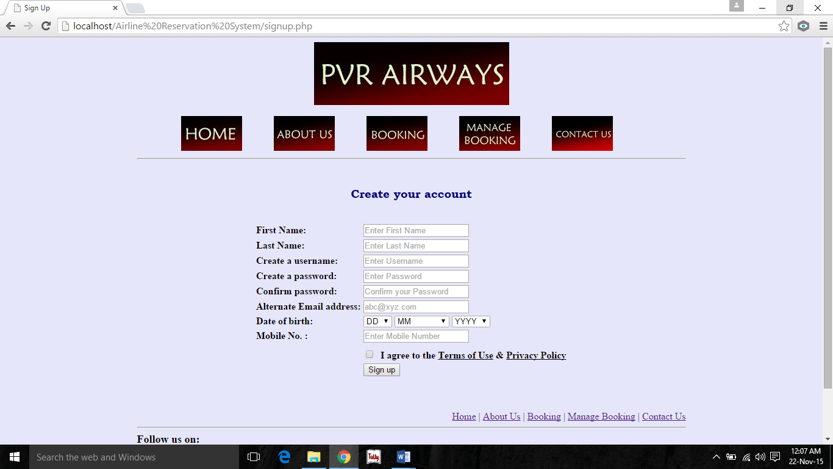

Figure 8.4 Register page

* **After Login:**

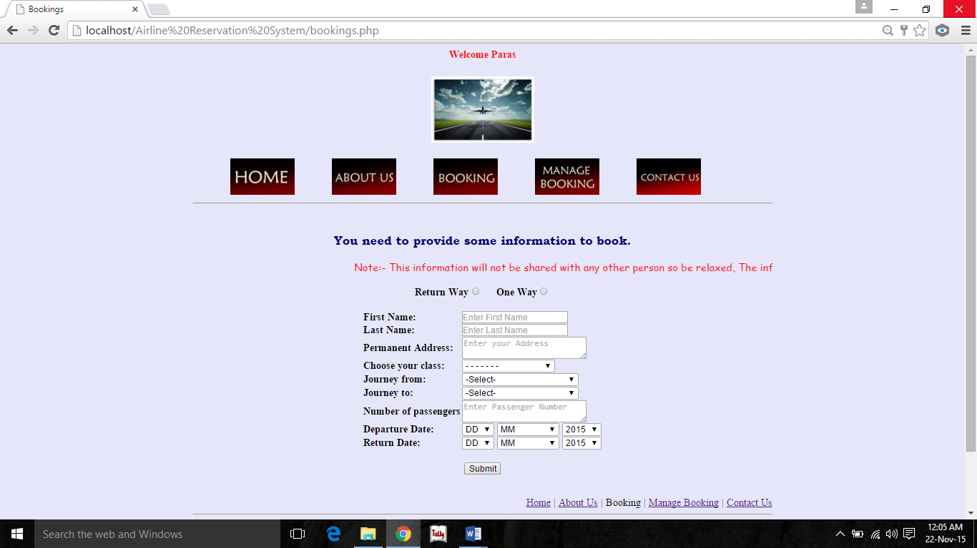

Figure 8.5 After Login

* **Offers:**

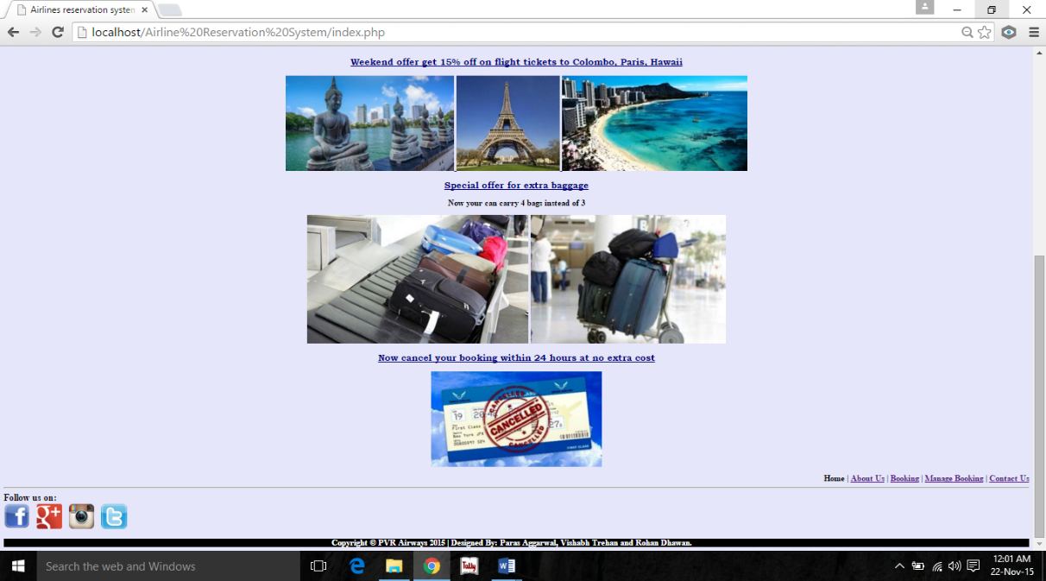

Figure 8.6 Offers

* **Booking page:**



Figure 8.7 Booking page

* **Contact Us:**

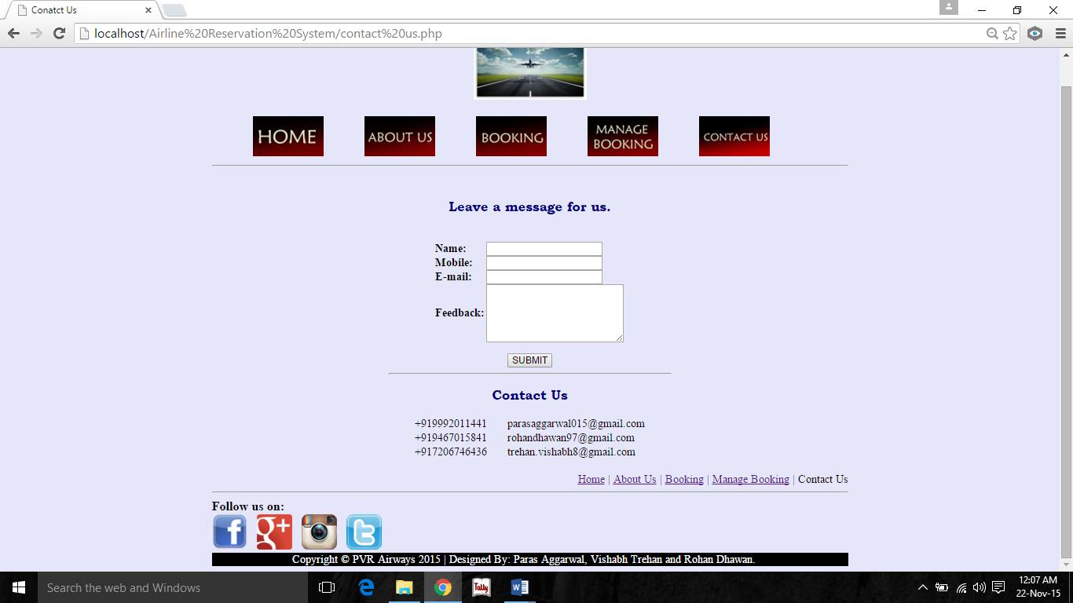

Figure 8.8 Contact Us

**CHAPTETR-9**

**SCREENSHOTS OF DATABASE**

* **Creating database**

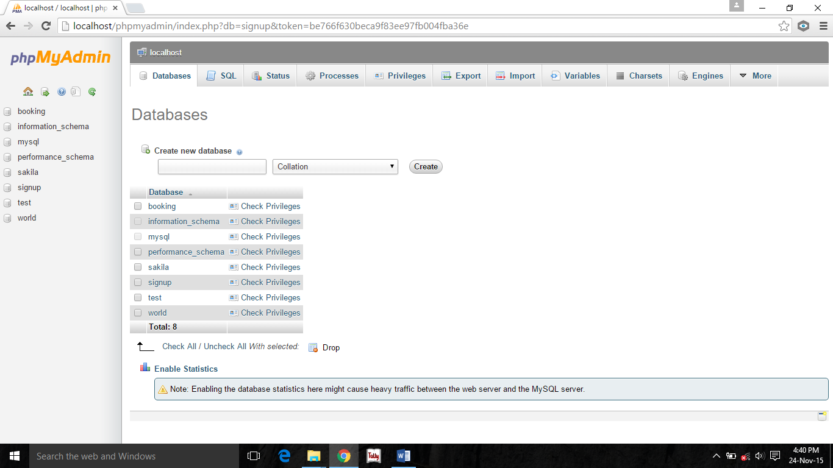

Figure 9.1 Creating database

* **Database created**

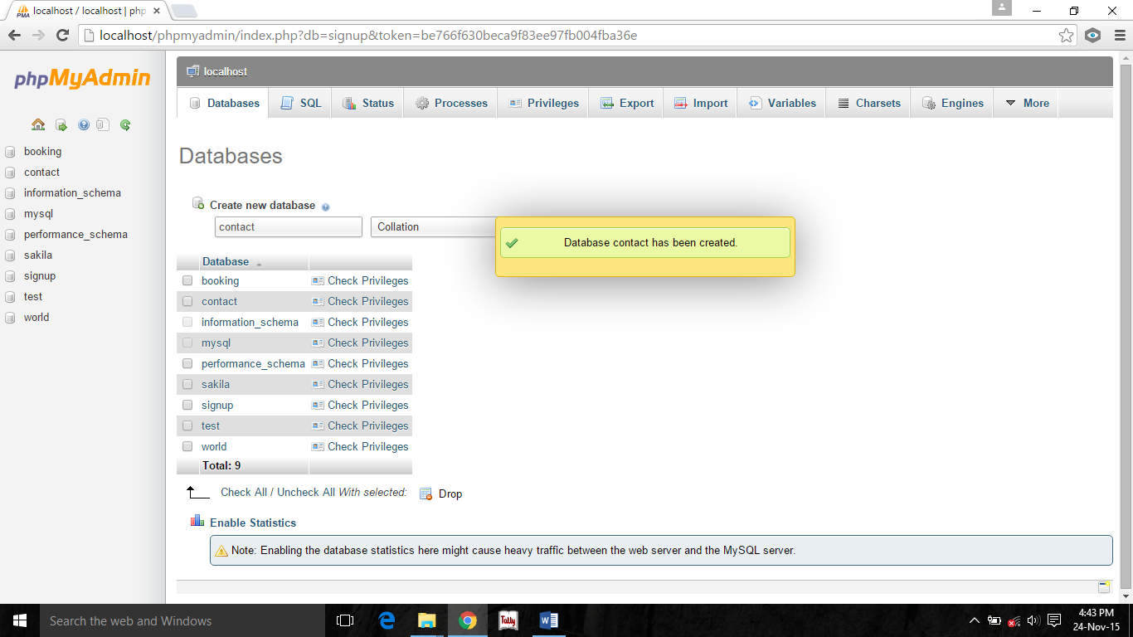

Figure 9.2 Database Created

* **Booking**

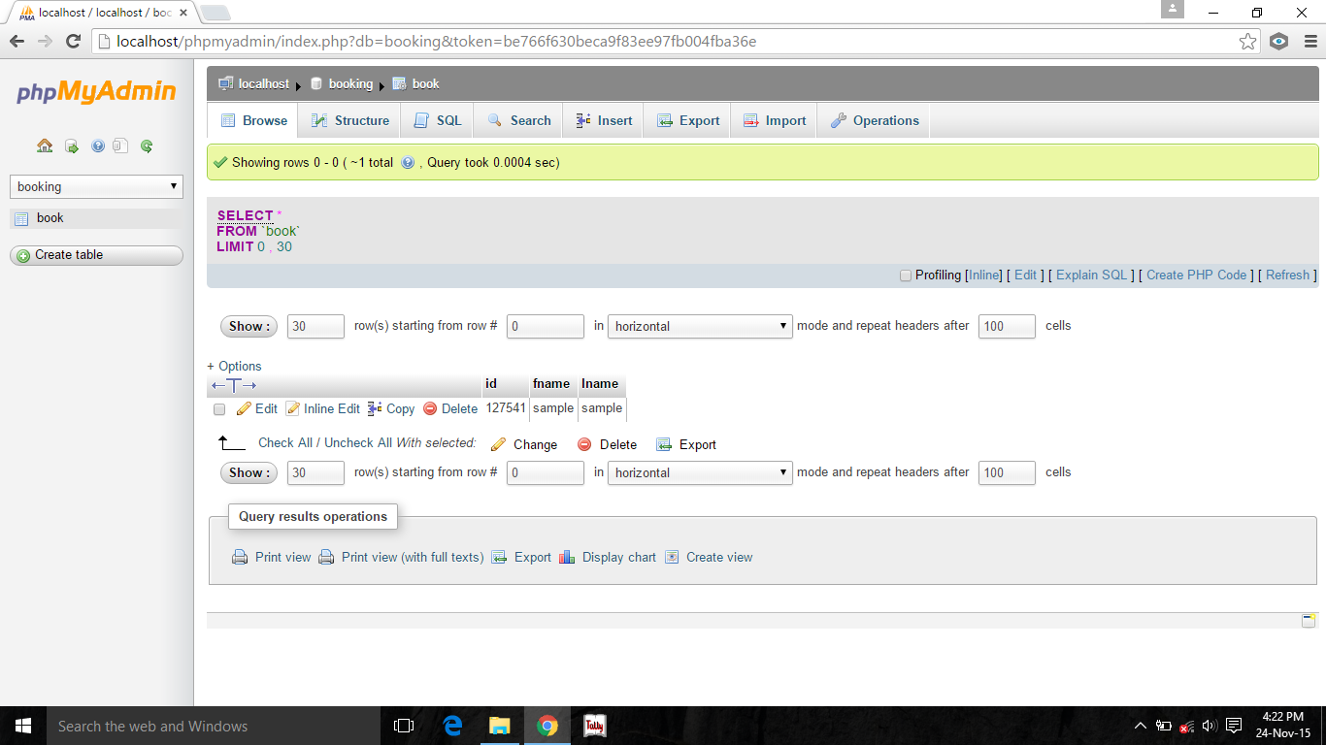

Figure 9.3 Bookings

* **Registration**

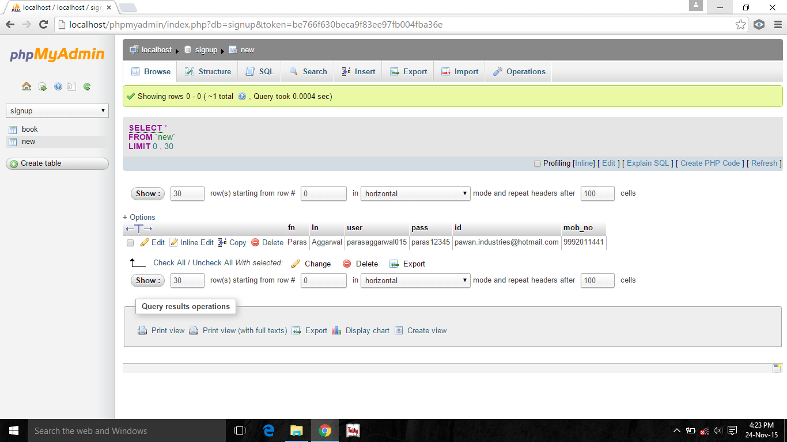

Figure 9.9 Registration

**BIBLIOGRAPHY**

* Learning PHP, MySQL & JavaScript by Robin Nixon
* http://php.net/
* http://www.w3schools.com/php/default.asp
* http://lpmj.net/
* Advanced php programming by scholossnagle.sams.
* A programmer introduction to php by w.j Gilmore Apress
* Beginning php 4 database by Deepak Thomas et al.wrox press ltd.
* Beginning php 4 programming by john blank et al.wrox press
* Core php programming by leon Atkinson
* Core php programming by leon Atkinson. Prentice
* Creating database web application with php by Charles river media.
* Dreamweaver MX : advanced php web development by Bruno mairlot
* Creating your web site with php by dmitriy koterov
* Making use of php by appu john wiley
* Multi-tier application planning with php by david wall
* MYSQL/PHP database application by greenspan.john
* Php cookbook by david sklar
* Php by ewample by Toby Butzon
* Php developer handbook by john coggeshall
* Php essentials by j. meloni
* Php pocket reference by rambus lerdorf.OReilly UK
* Web development with php by rick kennedy
* Php.net/link .php
* Php.net/manual/en/function.sym
* www.htmlgoodies.com
* www.motive.co.glossary
* www.hyperlinkcode.com
* https:/www.daniweb.com
* http://wordpress.com
* codingforums.com/php
* php.about.com
* http://stackoverflow.com/